Singapore University of Technology and Design  
Information Systems Technology and Design  
50.008 Database  
  
Online Bookstore Project

## Group Members

1. William Haw (1000---)
2. Scott Chiang Chun Wei (1000---)
3. Cheah Yew Hong, Kenneth (1000124)
4. Lee Ting’en Kevin (1000139)
5. Immanuella Lim Hao Ni (1000342)

## Key Folders

|  |  |
| --- | --- |
| **Path** | **Description** |
| BunsAndNoodle\ | Parent directory |
| BunsAndNoodle\SQL files | Contains the SQL files for the schema, triggers, and insertion of initial data |
| BunsAndNoodle\bns | Contains the application developed using NetBeans IDE 8.0.2 running on Glassfish Server 4.1 and MYSQL 5.6.2 |
| BunsAndNoodle\bns\web | Contains all of the JSP pages which were coded (please note that there are no separate java files; any java code snippets are contained within the JSP itself) |

## ER Diagram

Figure 1: ER Diagram

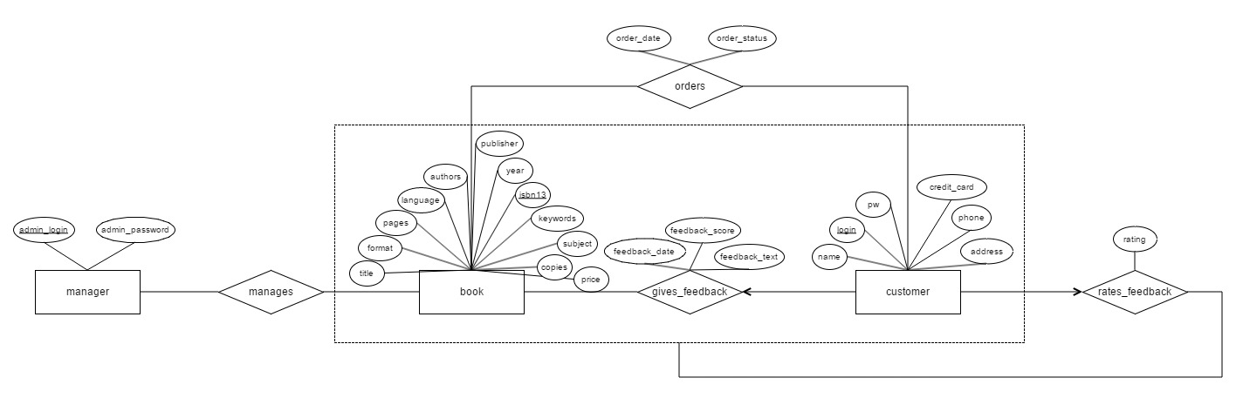

Based on the project requirements, we have designed the ER diagram above.

## Schema Design

We then proceeded to write the SQL statements for the tables based on the ER diagram, adding in additional CHECK constraints where it was applicable.

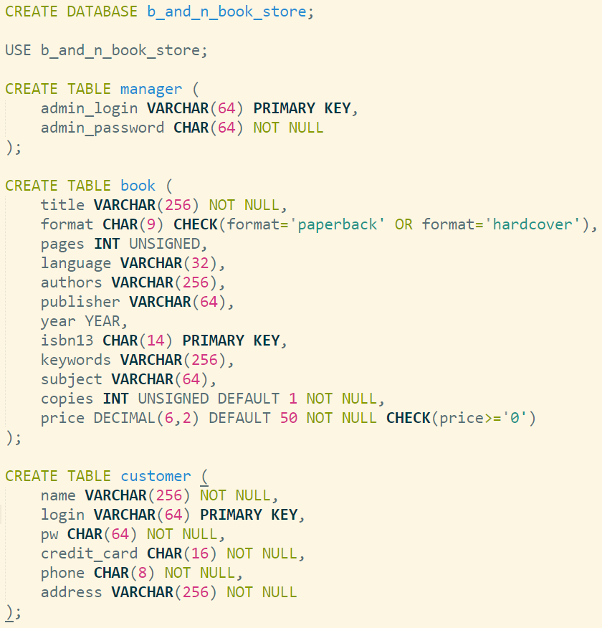  
Figure 2: SQL statements for the manager, book and customer entities

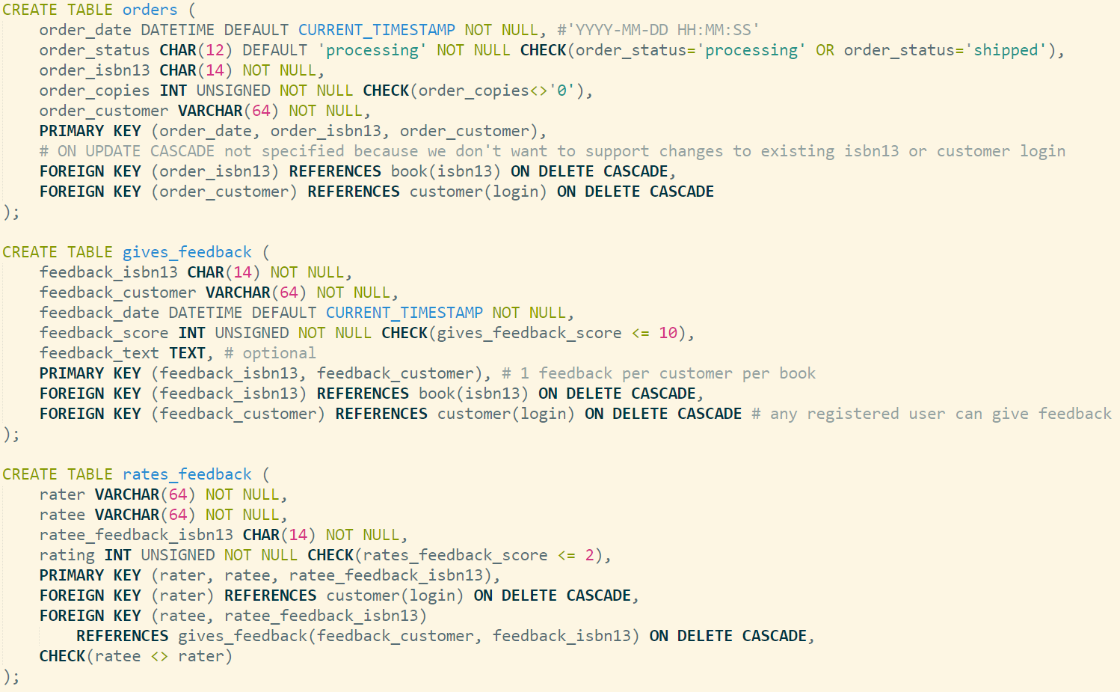  
Figure 3: SQL statements for the order, gives_feedback and rates_feedback relationships

## Implementing CHECK Constraints in MYSQL

Given that CHECK statements are parsed but not actually implemented in MYSQL, we created our own triggers to enforce the various CHECK constraints which we had created. For example, we needed to check that the book format is either ‘paperback’ or ‘hardcover’, or that the feedback score does not exceed 10, or that a customer cannot be rating his or her own feedback on a book etc. By enforcing such rules at the database level, it helped to ensure that the initial insertion of test data into the database conformed to those rules. It also minimized the likelihood of mistakes during application level development.

Here is a sample trigger which ensures the format of the book is either ‘paperback’ or ‘hardcover’ and that the book price cannot be negative.

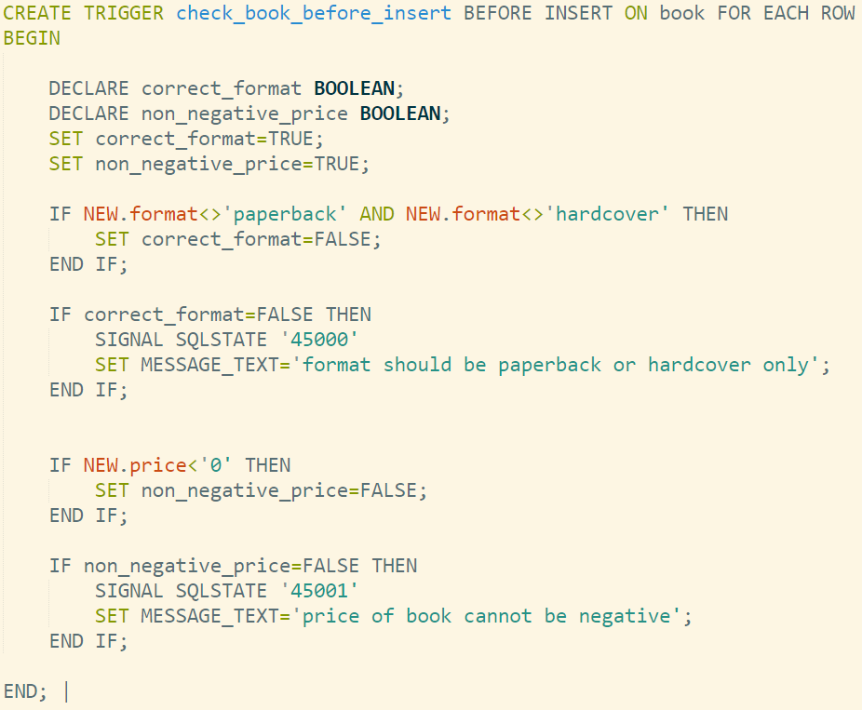  
Figure 4: Sample Trigger

The rest of the triggers are located in BunsAndNoodle\SQL files\2.Triggers.sql

## Initial Insertion of Test Data

As part of the development process, we had to create some dummy data for testing purposes. For example, after inserting the data, we tested out the various SQL queries to make sure they generated the correct output we wanted. Moreover, it allowed application developers to check if the results were being drawn out from the database and displayed on the webpage correctly.

In total, we inserted 100 legitimate books from 10 different subjects, 11 customers, 1 store manager, 3 orders, 10 book feedbacks (some feedbacks were applied to the same book by different customers so that we could calculate the average score) and 10 user ratings on the feedback given. Ultimately, we were selective about the initial data because we wanted to ensure that all requirements were thoroughly tested, such as the ability to sort book searches by average feedback score.

The SQL insertion statements for the various tables are located in BunsAndNoodle\SQL files\.

## SQL Queries

|  |  |
| --- | --- |
| **Query** | **Purpose** |
|  |  |
|  |  |
|  |  |
|  |  |
|  |  |
|  |  |
|  |  |
|  |  |
|  |  |
|  |  |
|  |  |
|  |  |
|  |  |
|  |  |
|  |  |
|  |  |

## Structure of Website

Insert in a pictorial summarizing the various redirects and pages involved (high level)

## Screenshots of Application

Insert in screenshots and short write-ups.